**Basic Interactive Operation Guide**



## **Introduction**

This guide focuses on the basic operation of Interactive, with emphasis on the three types of RAG components that must be included in it. Its purpose is to present clearly and simply the essence of the components, how to use them, and their importance in creating an efficient Interactive. This guide is part of a series of three guides dealing with Interactive and advanced ways to work with it optimally.

## **Uploading Documents to Agent**

When you want the agent to be able to work with information from documents, you can upload relevant documents to it as follows:

1. Enter the desired agent within the Agents tab and click the **Manage** button.
2. Click on the **Documents** tab.

תמונה שמכילה טקסט, גופן, לבן, גרפיקה

תוכן בינה מלאכותית גנרטיבית עשוי להיות שגוי., תמונה

1. Now you can choose by marking an entire document folder or individual files.

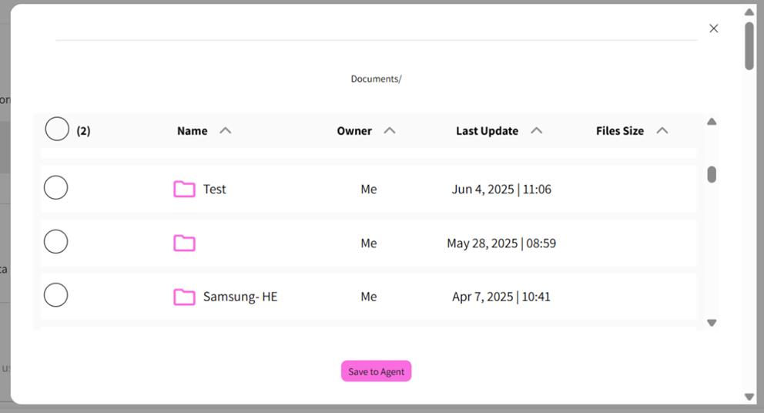

1. Click **Save to Agents** – this action will link the documents to the agent.

After documents are successfully added, an indication will appear on the agent card, indicating the number of documents attached (in parentheses next to the agent name).

תמונה שמכילה גופן, טקסט, לבן, גרפיקה

תוכן בינה מלאכותית גנרטיבית עשוי להיות שגוי., תמונה

## **Interactive**

An agent generator that enables creation and customization of agents according to user needs and based on organizational data.

To create an agent, click the **New** button and then **Interactive agent**, and fill in the agent name and fields in the pop-up that opens. Then click **Create**.

תמונה שמכילה טקסט, גופן, צילום מסך, עיצוב

תוכן בינה מלאכותית גנרטיבית עשוי להיות שגוי., תמונה

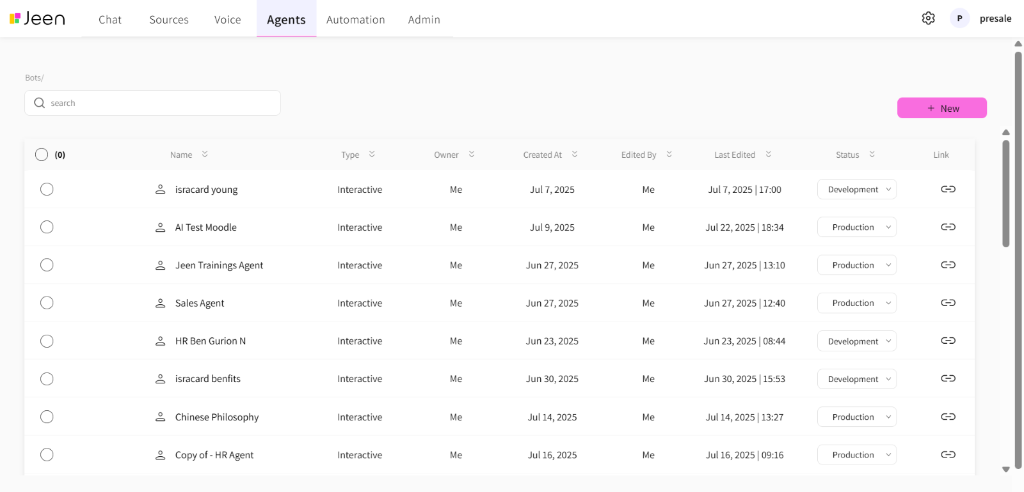

## **RAG Configuration Components**

Each agent contains several RAG components, where each component has a role in the agent's flow process. The components affect finding data relevant to the user's question, formulating the response, and the overall user experience. The components come in a template that is recommended to follow. Some templates contain short fields for manual user completion. **Fields marked with asterisks are intended for completion by the user. You should remove the example text and asterisks, and enter the relevant information for the specific agent instead.**

It is not mandatory to fill in all RAG components, and the components we are required to fill will change depending on whether it's an agent based on documents versus an agent not based on documents.

## **First Message**

The first message that will be displayed to the user in the agent. **Mandatory field.**

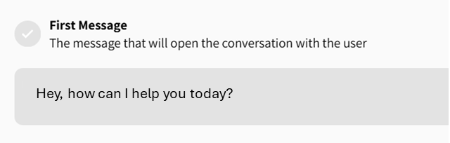

## **Classifier**

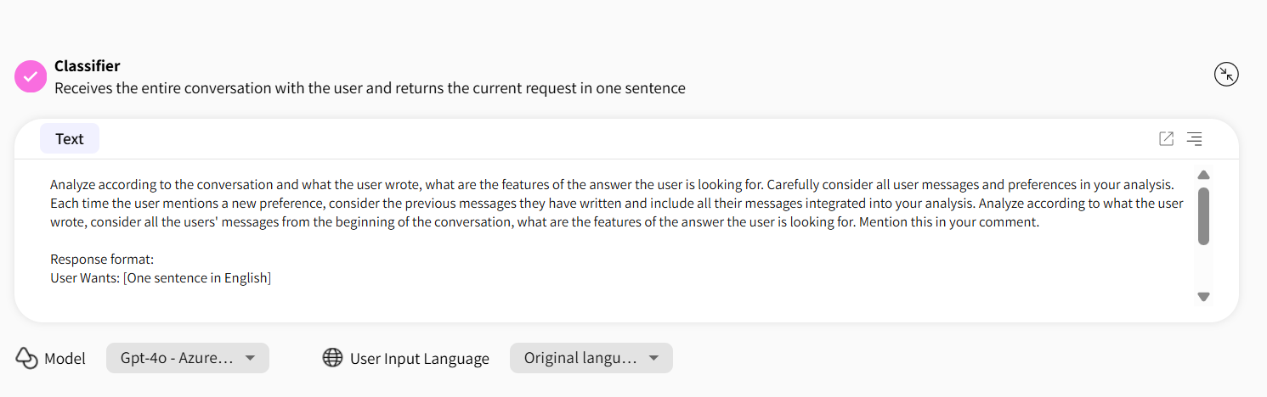

### **Component Purpose:**

A component whose purpose is to rephrase the user's question and refine it for the benefit of searching for the most appropriate answer or answers from the documents. Its main significance is to analyze the user's message in each message and thereby understand what the user wants.

### **What the Component Receives and Returns:**

Receives the entire conversation with the user and returns the current request in one sentence.

User Wants: [one sentence in English]

### **Editing Options:**

In the analysis prompt, we will define for the agent what format it should return the answer in:

User Wants: [One sentence in English]

Usually, we will add to the analysis prompt several examples of possible user desires, according to the agent's field of operation. **It is highly recommended not to change the prompt but only the examples for User Wants.**

### **Format:**

Format returned from the component:

User Wants: [one sentence in English]

### **Mandatory or Not:**

Not mandatory. If no Classifier is used, all messages sent by the user during the conversation will be sent to search as they are in the original languages, concatenated in order of sending, with a comma separating each message.

## **Ranking**

תמונה שמכילה טקסט, קו, גופן, צילום מסך

תוכן בינה מלאכותית גנרטיבית עשוי להיות שגוי., תמונה

### **Component Purpose:**

Receiving several possible answers and giving a score to each answer, plus filtering answers that don't necessarily fit the user's question. Through the Vectors Number, you can also define the amount of optional answers that will be returned from the documents as a response.

### **What the Component Receives and Returns:**

Receives the vectors (text segments) and gives each one a score according to their level of relevance.

### **Editing Options:**

**It is highly recommended not to change the prompt but only to adjust the threshold score written in sections 2 and 3 in the prompt to the threshold score we defined in Passing Grade.**

### **Format:**

Response format:

source1: [relevance score from 0 to 100]

source2: [relevance score from 0 to 100]

source3: [relevance score from 0 to 100]

source4: [relevance score from 0 to 100]

source5: [relevance score from 0 to 100]

### **Mandatory or Not:**

Not mandatory, but if we cancel it, there are two options:

1. If we later choose **Best Grade**, then the vector that will pass to Response is the one that receives the highest score from Cosine Similarity.
2. If we choose **All Above Passing Grade**, then all vectors we received from Cosine Similarity will pass to the Response component.

## 

## 

## 

## 

## **Response**

תמונה שמכילה טקסט, גופן, מספר, צילום מסך

תוכן בינה מלאכותית גנרטיבית עשוי להיות שגוי., תמונה, אובייקט מקובץ

### **Component Purpose:**

The component's purpose is to formulate the final answer to the user. Its role is to take the information sources that came as answers and refine the answer we received to the user's question. The component receives the list of sources after they passed filtering in Ranking. It receives background information about the agent, its purpose, important rules like basing only on the list of sources provided, and other rules specific to that agent.

### **What the Component Receives and Returns:**

Receives the vector(s) and the conversation with the user, formulates an optimal response, and returns it to the user.

### **Editing Options:**

It is recommended to add sections of additional examples, add information for the specific characteristics of the agent's needs. This can be done by filling in the content marked with asterisks.

Additionally, you can decide whether we want the component to be based only on the vector that received the highest score in Ranking, and in that case, choose **Best Grade**, or to be based on all vectors that passed the threshold score **All Above Passing Grade**.

### 

### 

### 

### **Response Message – Optional**

A message that will be sent to the user when no information relevant to what the user requested is found in the documents. This means that no vector was returned and passed the threshold score. If there is no Response message, the response will come from the Tone component.

### **Mandatory or Not:**

This component cannot be removed from agents that include documents, as it is essential for receiving answers based on the documents.

### **Important to Know:**

If there is no Tone, you must fill in the Response message – without it, the agent cannot be saved.

**You must not delete the first line that appears in the component's prompt:**

The List of Sources:

{List_of_sources}